Difference between Winged Termites and Winged Ants
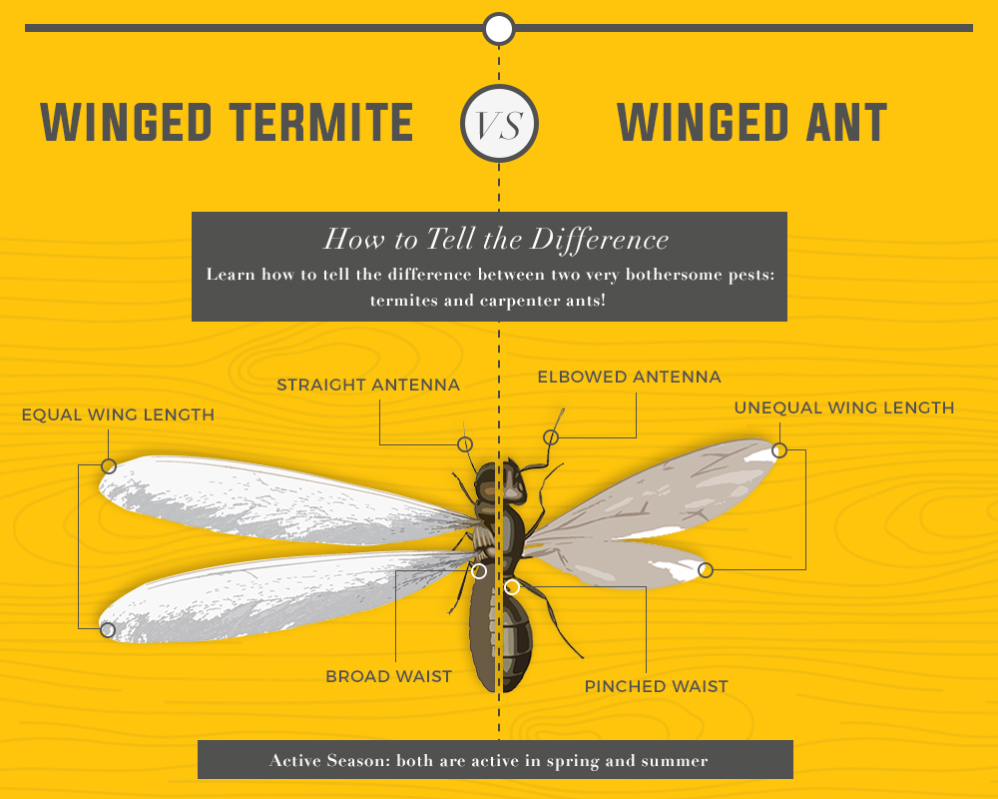
Termites have:
- straight antennae
- equal length wings
- straight waist
Flying ants have: 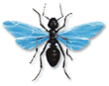
- bent antennae
- unequal length wings
- pinched waist

